The SWOT Analysis is used to point out Strengths, Weaknesses, Opportunities and Threats to the company. Strategies are developed to capitalize on strengths and to overcome weaknesses.

The MACRO SWOT Analysis is used to assess the company in relation to the marketplace. The MICRO SWOT Analysis is used to assess the company in relation to specific market segments.

Both the MACRO SWOT Analysis and the MICRO SWOT Analysis categorize information found in the Industry Analysis, Competitive Analysis and Company Background. They address the most relevant and actionable points. They focus on the Challenge and must be very objective.

To illustrate how a SWOT Analysis is constructed, we will consider a scenario where a company is a package goods food distributor that presently does not do business in Manhattan, but wants to.

Strengths:

We must convert Strengths into building blocks for strategies. When we word them, we keep the challenge in mind. For example, a strength uncovered in the Company Background indicates we do business in other territories with 8 of the 15 major supermarket chains servicing Manhattan. Another strength uncovered in the Competitive Analysis – while major competitors are based in New England and in the Baltimore/Washington areas, our local warehouse, located in the Bronx, provides easy access and quick turnaround for deliveries to Manhattan.

Weaknesses:

Weaknesses are obstacles we must overcome to resolve our challenge. The SWOT Analysis simply points them out. We must word weaknesses with the challenge in mind. For example, a fact uncovered in the Company Background indicates our company delivers to supermarkets by “dropping” trailer loads of products at their centralized warehouse locations. The weakness is Manhattan supermarkets require individual store “drops” with shelf-stocking service – the supermarkets want us to make deliveries to individual stores (not the centralized warehouse) and also want us to put our merchandise on their shelves for them. This weakness identifies an important element required by a strategy that will service Manhattan supermarkets if we wish to win their business.

Opportunities:

An opportunity is a chance to suggest a basic direction. Think of opportunities as items in a wish list. An opportunity should be worded as follows: “if we can do “whatever”, then we may realize a specific desirable result that will help us resolve the challenge. For example, “If we can arrange a cost-effective deal with a rack jobber to service individual supermarket stores in Manhattan for us then we may achieve distribution without incurring infrastructure costs and investment in trucks and employees.(A Rack Jobber is a company that delivers inventory to individual stores and places the merchandise on the shelves). Only focus on opportunities that will have a significant impact on the challenge.

Threats:

We must relate threats to the challenge. Think in terms of “What can happen that could impact the challenge negatively?” Be sure to focus on issues that can have a significant impact on our ability to resolve the challenge. Competitive actions and industry trends are the most likely candidates to cause harm. Only threats uncovered in the Industry, Competitive and/or Company analyses can be used. For example, “If competitors arrange “sweetheart deals” with supermarkets in exchange for shelf space we may have to use “Pull” tactics to fight for product placement on the shelf in the store. “Pull tactics” might be represented by handing out coupons for your product to encourage consumers who will redeem the coupons to bring them to the store to request the product, forcing the store to carry it. As with opportunities, we use “If – then” statements to present the threats we may face.

The following is an example of how a SWOT Analysis might be presented. This example includes only one item in each category. It is likely a SWOT Analysis will include many items in each category.

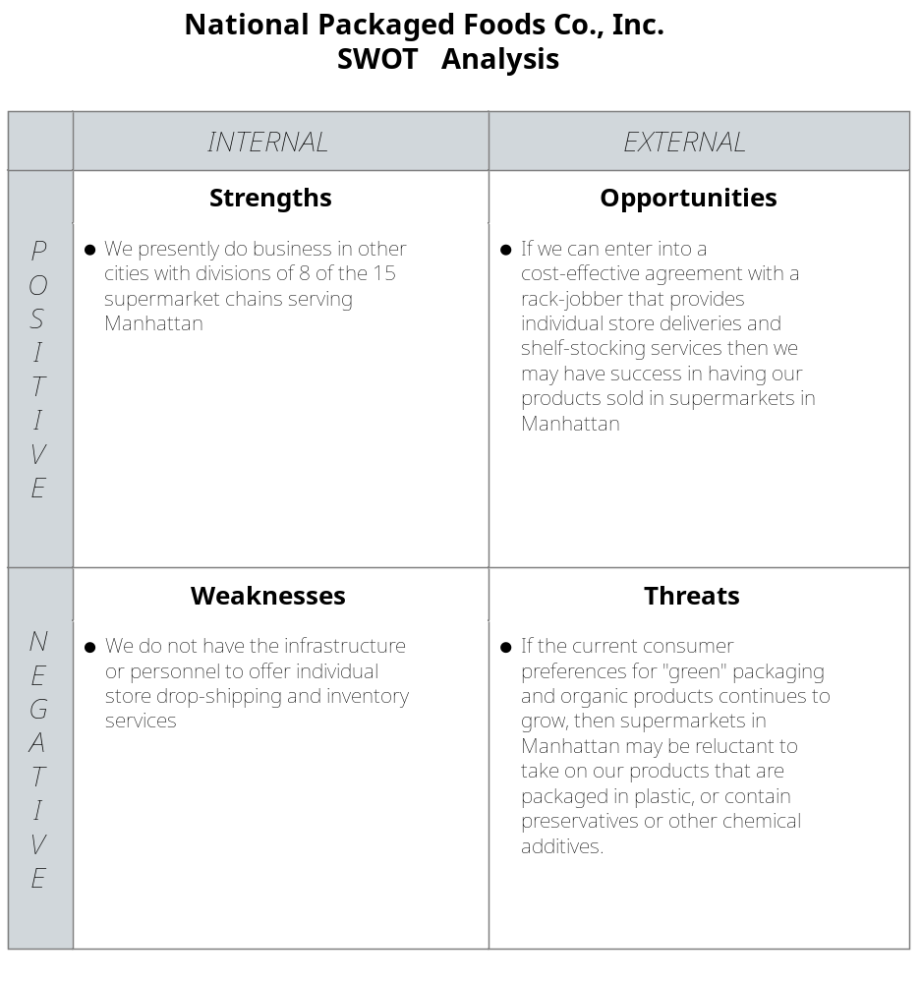

Reference 18: page 64: SWOT Analysis this framework is in the form of a matrix, and its name is an acronym for strengths, weaknesses, opportunities, and threats. It relates to the firm's capabilities --- or lack of them --- and how they may be leveraged to create potential for growth (opportunities) and factors that could negatively affect the firm (threats).

Reference 19: page 182: use SWOT analysis to identify strategic options. Strengths are characteristics of the business or team that give it an advantage over others in the industry. Weaknesses are characteristics that place the firm at a disadvantage relative to others. Opportunities are chances to make greater sales or profits in the environment, and threats are elements in the environment that could cause trouble for the business.

SWOT analysis is a strategic planning tool that looks critically at these factors. It is probably the best-known strategic planning tool. It is used to organize and perform an analysis of your company's current and future resources and situations. It provides one of the best ways to organize your thinking about how to pursue the benefits you have identified as important to your customers.

In a SWOT analysis, you gather information from yourself and others who know you, your company, the market, and the industry. Talking to potential customers is also a positive in SWOT analysis the questions are simply the SWOT topics: (what do you see as the opportunities and threats in the market or industry?" And "what do you see as the strengths and weaknesses of my firm?" You can obtain this information from formal or informal interviews, as well as from brainstorming sessions. Brainstorming is a group discussion in which people are asked to give their ideas and thoughts about a topic. In a brainstorming session there is one special rule --- nobody can criticize or put down an idea. The only types of questions that can be asked or to clarify what someone meant.

The mechanics of a SWOT analysis: take the responses from the sources and put them into a SWOT table like the one shown above. To analyze the ideas listed in the SWOT table start with opportunities. Identify the opportunities that seems strongest. Compare these to your strengths, looking for matches. For example, if there is an opportunity for "more post sales support" in a computer store and one of your strengths is "great at explaining computers," you would be well positioned to move on that opportunity.

Similarly, you compare threats to your weaknesses. A typical threat is "insufficient capital" for a startup. Then if you see "lack of capital" as one of your firm's weaknesses, you know where you need to put in extra effort. It also makes sense to do a cross comparison, such as strengths to threats and weaknesses to opportunities. This can point the way to solving problems. For example in the lack of capital problem, having a strengths such as "a large support network" might offer a way to look for the missing startup capital. Along the same lines, strong opportunities can offset weaknesses. For example, a lack of experience with the product is less of a weakness when the product is new and the demand for it is very high.

Examples of strengths as shown in this reference: (your examples in each of the categories will be more complete and thorough)

- customers ready to buy
- contracts for products or service
- adequate financial backing
- specialized knowledge
- strong support network
- trade secrets, secret recipes
- patents, trademarks, copyrights
- Brand or personal recognition
- location or facility advantages
- superior product/service or processes
- superior staff
- prior self-employment experience
- prior managerial experience
- prior sales experience
- prior experience in the industry
- prior experience in the locality
- prior experience in the market

Examples of weaknesses in this reference:

- customers not ready to buy
- inadequate financial backing
- easy to copy business
- weak or no support network
- on distinctive product, service, or Brand
- location or facility disadvantages
- inadequate staff
- lack of self-employment experience
- lack of managerial experience
- lack of sales experience
- lack of experience in the industry
- lack of experience in the locality
- lack of experience in the market

Examples of opportunities in this reference: (these have not been worded in a manner in which you are to word you are opportunities --- they are simply presented as examples of the subjects opportunities could consist of)

- supply shortages
- unutilized resources
- customer contracting
- second sourcing
- market relinquishment
- favored purchasing
- rule changes by government
- technology creating new products/services
- new markets opening up

Examples of threats in this reference: (the same comment as found under opportunities above applies here)

- economic downturn
- oversupply
- competitive pressures
- supplier/customer pressures
- major supplier/customer loss
- NIST window of opportunity
- negative government regulations or actions
- obsolescence from market or technology change

Page 185: At the end of the SWOT analysis, you have to make a decision about the strategic direction of the business. (Note from Myron: in our approach this will apply to a small degree after Macro SWOT analysis, and to a greater degree after Micro SWOT analysis for each individual segment). The options are generally described as: flaunt, fix, fight, or flee. You make the decision based on which pair of relations are the strongest. We're strengths match opportunities, you have the winning combination and you should flaunt and focus your efforts. Where a weakness gets in the way of pursuing an opportunity, you need to fix it or clear the way. Where you are firm faces a threat, the best approach is to fight it with your strengths. When you see a threat that is made worse by a weakness in your firm, the best strategy is often to flee, trying to keep the weakness from exacerbating the threat.

The final stage of SWOT analysis is to match it against the benefits sought by your market. Central to making this work is having your benefits come up in the opportunities you and others see for the industry and market. If not, you need to rethink the benefits based on what the SWOT analysis uncovered. Your strengths should match or support the benefits and your weaknesses should not get in the way of delivering the desired benefits. Threats that can challenge or limit the delivery of benefits to customers become a major hurdle that needs to be overcome before starting the business.

Reference 20: page 80: Integrating Internal and External Analyses

A solid foundation for competitive advantage requires a match between the strengths and weaknesses of the business and current opportunities and threats. This integration is best revealed through SWOT analysis, which provides a simple overview of avengers strategic situation. The following is a list of a number of factors that can be strengths, weaknesses, opportunities, and threats; however, these are merely representative of the countless possibilities that may exist.

POSITIVE FACTORS

Internal factors

Strengths:
- important core competencies
- financial strengths
- innovative capacity
- skilled or experienced management
- well-planned strategy
- effective entry wage
- protection from competitive threats
- positive reputation in the marketplace
- proprietary technology

External factors

Opportunities:
- untapped market potential
- new product or geographic market
- favorable shift in industry dynamics
- potential for market growth
- emerging technologies
- changes allowing foreign market entry
- deregulation
- increasing market fragmentation

NEGATIVE FACTORS

Internal factors

Weaknesses:
- inadequate financial resources
- poorly planned strategy
- lack of management skills or experience
- inadequate innovation
- negative reputation in the marketplace
- inadequate facilities
- distribution problems
- inadequate marketing skills
- production inefficiencies

External factors

Threats:
- new competitors
- rising demands of buyers or suppliers
- sales shifting to substitute products
- increased government regulation
- adverse shifts in the business cycle
- slowed market growth
- changing customer preferences
- adverse demographic shifts

In practice, a SWOT analysis provides a snapshot view of a company's current situation. This is unfortunate, since businesses perform better when they see their strategic setting as being in continuous motion. That is, companies perform better when they look forward, using their current capabilities to position their enterprises for business opportunities to come. In short, the high performing companies of the future will be those that improve on today's capabilities to meet the challenges of tomorrow.

Outside-in an inside-out approach is come together in the SWOT analysis to help an entrepreneur identify opportunities that match the venture. The entrepreneur can then determine the best opportunity by asking a few additional questions:

- Will the opportunity selected lead to others in the future?
- Will the opportunity helps to build skills that open the door to new opportunities in the future?
- Will pursuit of the opportunity be likely to lead to competitive responses by potential rivals?

Obviously, the most promising opportunities are those that lead to others (offering value and profitability over the long run), promote the development of additional skills that equipped the venture to pursue new prospects, and yet do not provoke competitors to strike back.

Hugh Kenneth Holyoak has learned how one business can lead to another and how new skills can open the floodgates of opportunity. Holyoak, owner of Ken's Hatchery and Fish Farms, to commercial lakes, and a wild pig hunting business, has introduced a number of fishy innovations over the years, including Kens Floating Raceways Fish Factory, the Scale-o-matic Electric Fish Scaler, and the E-Z Floating Fish Cage, and his own hybrid fish called the Georgia Giant. Noting that rising demand and disappearing wetlands have created a serious shortage of free range frogs for dining and dissecting, he set his sights on the frog farming business, offering an indoor frog raising system that can grow up to 1500 baby frogs on a mere 12 feet of floor space. Future prospects are bright indeed, given current demand. And because most frog farms are located in low-wage countries and use labor-intensive methods, competitive retaliation is unlikely. By setting his sights on frog farming, Holyoak found a way to match external developments (rising demand for frogs) would internal capabilities (fish raising know-how) with virtually no competition at the moment, related opportunities are sure to open up, and the skills Holyoak learns from the frog farming or likely to benefit is fish related operations as well.

Like most successful entrepreneurs, Holyoak discovered areas of business opportunities that tap into emerging potentials in the external environment, but he moved in the direction of those that match his personal capabilities and the strengths of his current businesses. As shown in the exhibit below this is an entrepreneurs "opportunity sweet spot."

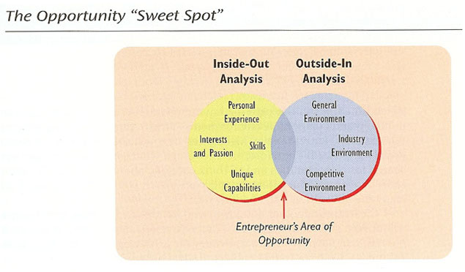

Reference 22: page 74: Environmental Analysis

Large and small businesses alike must operate in constantly changing environment. The ability to adapt to change is a major determinant of success or failure for any business in a free enterprise system. Essentially, an environmental analysis is the process in which a manager examines what is going on with in any sector that could affect the business, either within the business or outside of it.

Environmental analysis is also called SWOT analysis because you examine strengths, weaknesses, opportunities, and threats. An analysis of the internal environment identify strengths and weaknesses that exist within your own business. Analysis of the external environment identifies opportunities and threats --- factors outside your control --- that may affect your business.

Because of their speed, flexibility, and sensitivity to customer preferences, small businesses are in a position to quickly take advantage of changes in the environment. Environmental analysis is important to small businesses and costs they have fewer resources to risk no business can afford many mistakes, but the larger the operation, the more breadth it generally to absorb the cost of errors. A small business may be significantly affected by detrimental environmental changes that a larger business could more easily weather.

External Analysis Opportunities are positive alternatives that you may choose to help attain your company's mission. Although you should always be scanning for opportunities, you cannot pursue every one. Your strategic plan will help you identify those that are right for your business.

Threats are obstacles to achieving your mission or goals. They are generally events or factors over which you have no control: a change in interest rates, new government regulations, or a competitor's new product. Although you can not control these threats, you can prepare for them or take positive action to cope with them. Threats and opportunities can be found by scanning developments in the following environments:

- Economic. Much of the economic data readily available on the international and national levels are very valuable to small businesses operating in smaller more isolated markets. As a small business owner, you need to be aware of economic conditions that affect your target markets, such as unemployment rates, interest rates, total sales, and tax rates within your community.
- Legal/regulatory. Some factors can affect small businesses in more than one environment. For example, the passage of the North American Free Trade Agreement (NAFTA) change both regulations and the competitive environment. With regulations altered to encourage trade between the United States, Canada, and Mexico, many small businesses have found a wealth of new opportunity in new markets. Other businesses have seen the changes as a threat because they brought new competition.
- Socio-cultural. What members of society value and desire as they pass from one life stage to another has an effect on what they purchase. For example, the increased popularity of tattoos among teens and 20-somethings means opportunity for skin artists who are able to provide this service in a small business. Will the next opportunity for an entrepreneur be an innovative new process for removing those tattoos?
- Technological. If technology is the application of scientific knowledge for practical purposes. Few environmental forces have caused as much excitement in the business community as the emergence of the Internet. Entrepreneurs are scrambling to find ways to take advantage of the opportunities of the e-business.
- Competitive. Actions of your competitors are considered forces within your competitive environment. You face a difficult task in not only tracking what your competitors are currently doing, but also predicting their reactions to your moves. If you drop the price of your product to gain more market share, will competing business managers react by holding their prices constant or by cutting their prices below yours? This situation could escalate into an expensive price war.

Our opportunities and threats easy to identify? No, and they never have been. Writer Mark Twain once said, "I was seldom able to see an opportunity until it ceased to be one."

Internal Analysis and internal analysis assesses the strengths and weaknesses of your company. It identifies what it is that your company does well and what it could do better. Internal analysis is important for two reasons. First, since your personal opinion of your own business is sure to be biased (we tend to look at ourselves through the proverbial rose-colored glasses), you need an objective analysis of the capacity and potential of your business. Second, any internal analysis can help you match the strengths of your business with the opportunities that exist. The idea is to put together a realistic profile of your business to determine whether you can take advantage of opportunities and react to threats identified in the environmental analysis. This isn't as easy as it sounds, because you have to view your environments not as if they are snapshots, but rather as several videos playing simultaneously. The key is to match opportunities that are still unfolding with resources that are still being acquired.

Although most of us have no problem identifying restraints, some of us may need help with realizing era weaknesses. The following diagnostic tests can help you evaluate your business realistically:

- Visit your newest, lowest-level employee. Can she tell you why the business exists? Name major competitors? Say what you do well? List of major customers? If not, your vision isn't coming across.
- Can that same employee described what he is doing to contribute to your competitive advantage?
- Ask a long-term employee how things went yesterday. If you get answers like "okay" or "fine... just fine," you may have a potential problem. If you hear specifics, consider it a good sign.
- Observe what the business looks like after hours. Is the place neat and orderly or does it look like a tornado struck? Although he is doesn't guarantee success, you should be able to find the checkbook, phone book, and most of the furniture.
- Observe your business during work hours. Invent a reason to go where you can watch and hear what goes on. What impression do you get out of the business?
- . Ask them how they were treated the last time they were in your business, and emphasize that you would like an honest answer.
- Call your business during the busiest part of the day. How quickly is the phone answered? Is the response efficient, friendly, surly, or overly chatty?
- Ask a friend to visit your business as a mystery shopper. Would he come back again?

Reference 23: page 162: SWOT Analysis

To one of the most productive and memorable planning tools is a SWOT analysis. This is a self-assessment framework for examining our springs and weakness is, our opportunities and threats. Strengths include the pockets of excellence in the firm, perhaps a strong sales office in Birmingham, a good supply relationship with XYZ, a good inventory system, or a solid financial position. Grainger boasts a superior order fulfillment system, strong customer relationships, and product knowledge. Weaknesses are also characteristics of the firm itself and may include products with poor market positions, a lame channel of distribution overseas, a disadvantageous cost structure, or yesterday's technology. Aging assets, a locational disadvantage, or thinning talent in a key area represents weaknesses.

In this level of analysis, opportunities are favorable conditions in the firm's task environment. They can be recognized in access to growing markets, a market of escalating distribution service standards -- standards we can meet --- and new laws or regulations that might foreclose competitors. Threats are potential adverse conditions in the firm's environment. A margin squeeze from vigorous price competition and increasing input prices is a threat, as is a regulation that forecloses a particular input or distribution option. Grainger recognizes the threat from increasing service expectations -- faster, better, cheaper --- from its customers. A SWOT analysis may be one of the key working documents for goal setting and the revelation of distinctive competencies.

Page 163: A good SWOT analysis as several distinguishing characteristics. First, it is honest. Despite its receiving three professional war with awards for design excellence, it would be wrong to consider your firms design team a strength if consumer acceptance is low or there have been departures of key personnel. An honest label on the strength would be a "strong reputation among product design professionals."

Second, the analysis must be brought into focus. A distributor assessing trends for opportunities and threats should look at situations in markets outside its trade area. For example, T-Shirt City, a Midwestern wholesaler of shirts and sportswear to the screen printers and embroidery business, has observed margins shrinking across the country, as witnessed consolidation at the manufacturing and wholesaling level, and has seen its thinning customer base replicated in other markets.

The anticipation of customer needs requires a close look at the competitive pressures paced by each customer or customer group. Similarly, the business environment of direct and indirect suppliers must be considered. We also recommend that SWOT analysis be conducted at different levels: key products, lines of business, divisions, and countries.

Third, a SWOT analysis should consider multiple time horizons and label features of each dimension as such. For example, a drought in the Grain Belt is an immediate threat to flower and serial processors; its impact on costs and eventual market prices must be considered. Firms in this industry such as Peavy and Cargill should also look at head to new transport systems that may make inputs accessible that are currently remote. Evidence of new dietary habits, signs of breakthroughs in the grain preservatives, an emerging package recycling imperatives ought to be considered. Even the door ability of current strengths must be factored into the analysis.

Finally, because the slot analysis is built on perceptions of the firm and its environment, it is good to get the perceptions from several individuals or groups. Have purchasing, marketing, sales, human resources, and traffic departments each do SWOT analyses. They should broaden the scope of the analysis and capture strategic implications that stem from a variety of assumptions.

SWOT Recap
it takes two mirrors to show how the back of your hair was cut. And most of us also run our fingers through it. A SWOT analysis works similarly. It begins with a good look at the enterprise -- front, back, up close, down deep. And it takes stock of the firms and external environment. How has it changed in the last few periods? What do we anticipate in the time ahead? Is our firm poised for success in the current and anticipated environment? Are we ready to track the changing environment and maintain a leadership position they're in? Or have we faced up to the reality of our problems? Perhaps the discomfort of the recent period can no longer be endured. Maybe top management is ready to lead the firm to make radical change. Whatever the case, an honest, broad, and timely examination from multiple perspectives is needed for reliable self-assessment by SWOT.

Reference 13: page 42: Situation Analysis

The next section of the marketing plan is the situation analysis, which summarizes all pertinent information obtained about three key environments: the internal environment, the customer environment, and the firms external environment. The analysis of the firm's internal environment considers issues such as the availability and deployment of human resources, the age and capacity of equipment, or technology, the availability of financial resources, and the power and political struggles within the firms structure. In addition, this section summarizes the firm's marketing objectives and performance. The analysis of the customer environment examines the current situation with respect to the needs of the target market (consumer or business), anticipating changes in these needs, and how well the firms products presently meet these needs. Finally, the analysis of the external environment includes relevant external factors -- competitive, economic, socio-cultural, political/legal, and technological -- that can exert considerable direct and indirect pressures on the firm's marketing activities.

A clear and comprehensive situation analysis is one of the most difficult parts of developing a marketing plan. This difficulty arises because the analysis must be both comprehensive and focused on key issues in order to prevent information overload --- a task actually made more complicated by advances in information technology. The information for a situation analysis can be obtained internally through the firms information system, or it made have to be obtained externally through primary or secondary marketing research. Either way, the challenge is often having too much data and information to analyze rather than having too little.

SWOT (Strengths, Weaknesses, Opportunities, and Threats) Analysis to SWOT analysis focuses on the internal factors (strengths and weaknesses) and external factors (opportunities and threats) -- derived from the situation analysis in the proceeding section -- that gives the firms certain advantages and disadvantages in satisfying the needs of its target markets. These strengths, weaknesses, opportunities, and threats should be analyzed relative to market needs and competition. This analysis helps the company determined what it does well and where it needs to make improvements.

SWOT analysis has gained widespread acceptance because it is a simple framework for organizing and evaluating a company's strategic position when developing a marketing plan. However, like any useful tool, SWOT analysis can be misused unless one conducts the appropriate research identified key variables that will affect the performance of the firm. A common mistake in SWOT analysis is the failure to separate internal issues from external issues. Strengths and weaknesses are internal issues unique to the firm conducting the analysis. Opportunities and threats are external issues that exist independently of the firm conducting the analysis. Another common mistake is to list the firm's strategic alternatives as opportunities. However, alternatives belong in the discussion of marketing strategy, not in the SWOT analysis.

At the conclusion of the SWOT analysis, the focus of the marketing plan shifts to address the strategic focus and competitive advantages to be leveraged in the strategy. The key to developing strategic focus is to match the firms is strengths with its opportunities to create capabilities in delivering value to customers. The challenge for any firm at this stage is to create a compelling reason for customers to purchase its products over those offered by competitors. It is this compelling reason that then becomes the framework or strategic focus around which the strategy can be developed.

MAKING SWOT ANALYSIS Productive

Whether a firm receives the full benefits of SWOT analysis depends on the way that the manager uses the framework. If done correctly and smartly, SWOT analysis can be a viable mechanism for the development of the marketing plan. If done haphazardly or incorrectly, it can be a waste of time and other valuable resources. To help ensure that the former, not the latter, takes place, we offer the following directives to make SWOT analysis more productive and useful.

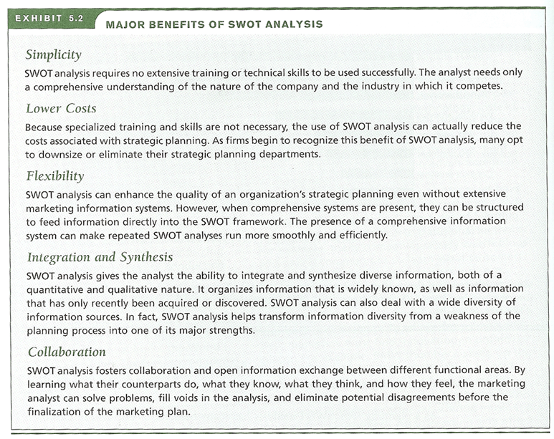

Page 120: Stay Focused

Marketing planners often make the mistake of conducting one generic SWOT analysis for the entire organization or business unit. Such an approach produces stale, meaningless generalizations that come from the tops of managers' heads or from press release files. Although this type of effort may make managers feel good and provide a quick sense of accomplishment, it does little to add to the creativity and vision of the planning process.

When we say he SWOT analysis, we really need SWOT analyses. In most firms, there should be a series of analyses come each focusing on a specific product-market combination. For example, a single SWOT analysis for the Chevrolet division of General Motors would not be focused enough to be meaningful. Instead, separate analyses for each product category (passenger cars, trucks, minivans) or brand (Corvette, Impala, Avalanche, Tahoe, Uplander) in the division would be more appropriate. Such a focus enables the marketing manager to look at the specific mix of competitors, customers, and external factors that are present in a given market. Chevrolets Tahoe, for example, competes in the crowded SUV market in which the auto industry releases new models at a staggering pace. Consequently, market planning for the Tahoe should differ substantially from market planning for Chevrolets Corvette or Uplander minivan. If needed, separate product-market analyses can be combined to examine the issues relevant for the entire strategic business unit, and business-unit analyses can be combined to create a complete SWOT analysis for the entire organization. The only time a single SWOT analysis would be appropriate is when an organization has only one product-market combination.

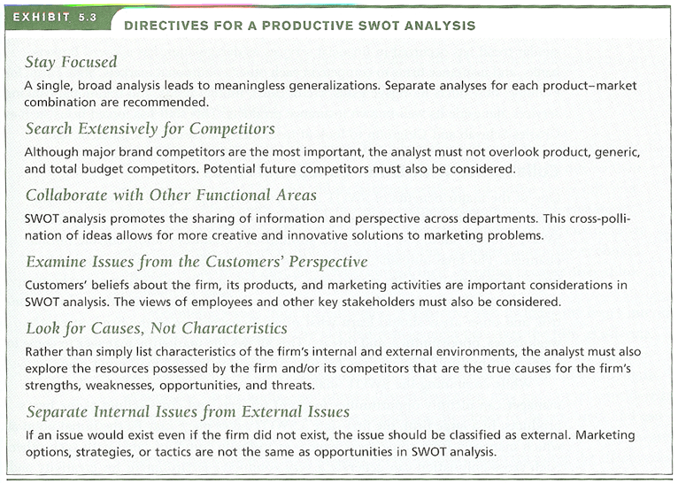

Search Extensively For Competitors

Information on competitors and their activities is an important aspect of the well focused SWOT analysis. The key is not to overlook any competitor, whether a court rival one on the Verizon. As we discussed in Chapter 4, the firm will focus most of its efforts on brand competition. During the SWOT analysis, however, the firm must watch for any current or potential direct substitutes for its products. Product, generic, and total budget competitors are important as well. Looking for all four types of competition is crucial because many firms and managers never look past brand competitors. Although it is important for the SWOT analysis to be focused, it must not be myopic.

Even industry giants can lose sight of their potential competitors by focusing exclusively on brand competition. Codec, for example, had always taken steps to maintain its market dominance over Fuji, Konica and Polaroid in the film industry. However, the advent of digital photography added Sony, Nikon, and canyon to Kodak's set of competing firms. And, as digital cameras became better integrated into wireless phones, Kodak will have to add Motorola, LG, Samsung, and Nokia to its competitive set. A similar trend has occurred in financial services as deregulation has allowed brokers, banks, and insurance firms to compete in each other's traditional markets. State Farm, for example, now offers mortgage loans, credit cards, mutual funds, and traditional banking services alongside its well-known insurance products. This shift has forced firms such as Charles Schwab and Citigroup to look at insurance companies in a different light.

Collaborate with Other Functional Areas

One of the major benefits of SWOT analysis is that it generates information and perspective that can be shared across a variety of functional areas in the firm. The SWOT process should be a powerful stimulus for communication outside normal channels. The final outcome of a properly conducted SWOT analysis should be a fusion of information from many areas. Manages in sales, advertising, production, research and development, finance, customer service, inventory control, quality control, and other areas should learn what other managers see as the firm's strengths, weaknesses, opportunities, and threats. This allows the marketing manager to come to terms with multiple perspectives before actually creating the marketing plan.

While combining the SWOT analysis from individual areas, the marketing manager can identify opportunities for joint projects and cross-selling of the firm's products. In a large firm, the first time a SWOT takes place may be the initial point at which managers from some areas have ever formally communicated with each other. Some cross-pollination can generate a very conducive environment for creativity and innovation. Moreover, research has shown that the success of introducing a new product, especially a radically new product, is extremely dependent on the ability of different functional areas to collaborate and integrate their differing perspectives. For example, every time that BMW develops a new car, they relocate 200 to 300 engineering, design, production, marketing, and finance employees from their worldwide locations to the company's research and innovation Center. For up to three years, these employees work alongside BMWs research and development team in a manner that speeds communication and car development.

Examine Issues From The Customer's Perspective

In the initial stages of SWOT analysis, it is important to identify issues exhaustively. However, all issues are not equally important with respect to developing competitive advantages and strategic focus for the marketing plan. As the analysis progresses, the marketing manager should identify the most critical issues by looking at each one through the eyes of the firm's customers. To do this, the manager must constantly ask questions such as the following:

- What do customers (and non-customers) believe about us as a company?
- What do customers (and noncustomers) think of our product quality, customer service, price and overall value, convenience, and promotional messages in comparison to our competitors?
- Which of our weaknesses translate into a decreased ability to serve customers (and decreased ability to convert noncustomers)?
- How do trends in the external environment affect customers (and noncustomers)?
- What is the relative importance of these issues, not as we see them, but as customers see them?
Marketing planners must also gauge the perceptions of each customer segment that the firm attempts to target. For example, older banking customers, due to their reluctance to use ATMs and online banking services, they have vastly different perceptions of the bank's convenience and younger customers. Each customer segments perceptions of external issues, such as the economy or the environment, are also important. It matters little, for example, that managers think the economic outlook is positive if customers have curbed their spending because they think the economy is weak.

Examining issues from the customers' perspective also includes the firm's internal customers: its employees. The fact that management perceives the firm is offering competitive compensation and benefits is unimportant. The real issue is what the employees think. Employees are also a valuable source of information on strengths, weaknesses, opportunities, and threats that management may have never considered. Some employees, especially front-line employees, are closer to the customer and can offer a different perspective on what customers think and believe. For example, research indicates that employees are a valuable source of information regarding the effectiveness of a firms advertising. Other key stakeholders, such as investors, the general public, and government officials, should also be considered. The key is to examine every issue from the most relevant perspective. Exhibit 5.4 illustrates how taking the customers' perspective can help managers interpret the clichés they might develop and then break them down into meaningful customer-oriented strengths and weaknesses.

Taking the customers' perspective is a cornerstone of well-Don SWOT analysis. Managers have a natural tendency is he issues the way that they think they are (for example, "we offer a high-quality product"). Swot analysis forces managers to change their perceptions to the way that customers and other important groups see things (for example, "the product offers weak value given its price and features as compared against the strongest brand competitor"). The contrast between these two perspectives often leads to the identification of the gap between management's version of reality and customers' perceptions. As the planning process moves ahead, managers must reduce or eliminate these gap and determine whether there were viewed as the firm are realistic.

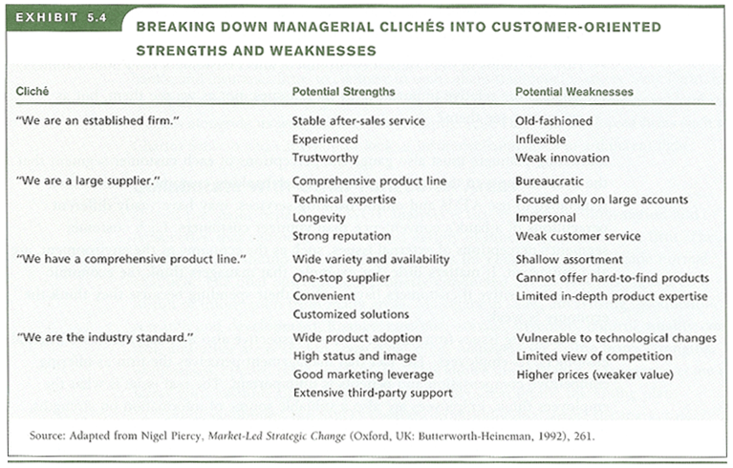

Look for Causes, Not Characteristics

Although taking the customers' perspective is important, it often provides just enough information to get into serious trouble. That is, it provides a level of detail that is often very descriptive, but not very constructive. The problem lies in listing strengths, weaknesses, opportunities, and threats as simple descriptions are characteristics of the firm's internal and external environments without going deeper to consider the causes for these characteristics. Although the customers' perspective is valuable, customers do not see behind the scenes to understand the reasons for a firms characteristics. More often than not, the causes for each issue in it a SWOT analysis can be found in the resources possessed by the firm and/or its competitors.

From a resource-based viewpoint, every organization can be considered as a unique bundle of tangible and intangible resources. Major types of these resources include the following:

- Financial Resources cash, access to financial markets, physical facilities, equipment, raw materials, systems and configurations
- Intellectual Resources expertise, discoveries, creativity, innovation
- Legal Resources patents, trademarks, contracts
- Human Resources employee expertise and skills, leadership
- Organizational Resources culture, customs, shared values, vision, routines, working relationships, processes and systems
- Informational Resources customer intelligence, competitive intelligence, marketing information systems
- Relational Resources strategic alliances, relations with customers, vendors, and other stakeholders, bargaining power, switching costs
- Reputational Resources brand names, and symbols, image

The availability or lack of these resources are the causes for the firm's strengths and weaknesses in meeting customers' needs and determine which external conditions represent opportunities and threats. For example, Wal-Mart's strength in low-cost distribution and logistics comes from its combined resources in terms of distribution, information, and communication infrastructure; committed employees; and strong relationships with vendors. Likewise, three and the strength in product innovation is the result of combined financial, intellectual, legal, organizational, and informational resources. These resources not only give Wal-Mart and three M. strengths or advantages in serving customers but also create imposing threats for their competitors.

Separate Internal Issues from External Issues

For the results of a SWOT analysis to be truly beneficial, we have seen that the analyst must go beyond simple descriptions of internal and external characteristics to explore the resources that are the foundation for these characteristics. It is equally important, however, many analysts to maintain the separation between internal issues and external issues. Internal issues on the firm's strengths and weaknesses, whereas an external issues referred to opportunities and threats in the firm's external environments. The key test to differentiate a strength or weakness from an opportunity or threat is to ask, "would this issue exist if the firm did not exist?" If the answer is yes, the issue should be classified as an external.

At first glance, the distinction between internal and external issues seems simplistic and immaterial. However, the failure to understand the difference between internal and external issues is one of the major reasons for a poorly conducted SWOT analysis. This happens because managers tend to get ahead of themselves and list their marketing options or strategies as opportunities. However, options and strategies are not the same as opportunities in the SWOT framework. Opportunities (and threats) exist independently of the firm and are associated with characteristics or situations present in the economic, customer, competitive, socio-cultural, technological, political or legal environments in which the firm resides. A managers options, strategies or tactics should be based on what the firm intends to do about its opportunities and threats relative to its own strengths and weaknesses. The development of strategic options occurs at a later point within the marketing plan framework.

In summary, a SWOT analysis should be directly by Socrates' advice: "know thyself." This knowledge should be realistic, based on how customers (and external and internal) and other key stakeholders see the company, and viewed in terms of the firm's resources. If managers find it difficult to make an honest and realistic assessment of these issues, they should recognize the need to bring in outside experts or consultants to oversee the process.

Reference 4: page 46: Assessed the Company's Strengths and Weaknesses

Having defined the vision and the mission of the business, entrepreneurs can turn their attention to assessing company strengths and weaknesses. Competing successfully demands of the business create a competitive strategy that is built on and exploits its strengths and overcomes or compensates for its weaknesses. Strengths are positive internal factors that contribute to the accomplishment of a company's mission, goals, and objectives. Weaknesses are negative internal factors that inhibit the accomplishment of its mission, goals, and objectives.

Identifying strengths and weaknesses helps an entrepreneur understand his or her business as it exists (or will exist). An organization's strengths should originate in its core competencies because they are essential to its ability to remain competitive in each of the market segments in which it competes. The key is to build a successful strategy by using the company's underlying strengths as its foundation and matching those strengths against competitors weaknesses.

One effect of technique for taking a strategic inventory is to prepare a balance sheet of the company strengths and weaknesses. The positive side should reflect important skills, knowledge, or resources that contribute to the company's success. The negative side should record honestly any limitations that detract from the company's ability to compete. This balance sheet should analyze all key performance areas of the business -- human resources, finance, production, marketing, product development, organization, and others. This analysis should give owners a more realistic perspective of their business, pointing out foundations on which they can build futures strengths and obstacles that they must remove for business progress. This exercise can help owners move from their current position to future actions.

Scan the Environment for Significant Opportunities and Threats Facing the Business

Opportunities. Once entrepreneurs have taken an internal inventory of company strengths and weaknesses, they must turn to the external environment to identify any opportunities and threats that might have a significant impact on the business. Opportunities are positive and external options that the firm could employee to accomplish its objectives. The number of potential opportunities is limitless, so managers need to analyze only factor significant to the business (probably two or three at most). Otherwise, they may jeopardize their core business by losing focus and trying to do too much at once.

When identifying opportunities, entrepreneurs must pay close attention to new potential markets. Are competitors overlooking a niche in the market? Is there a better way to reach customers? Are customers requesting new products or product variations? Have environmental changes created new markets? After spending years working for large companies selling skincare and makeup to women, Emily Dalton and Curran Dandurand recognize the potential to sell similar products to men. "We knew there was a huge opportunity with men," says Dandurand. Before launching their business, Jack Black, Dalton and Dandurand conducted extensive research on their target customers to discover exactly what men want it and would buy. According to Dalton, their target customer "cares about how he looks, but he's not going to go through a five-step skin-care regimen." Recognizing their customers needs, the partners built their product line around simplicity and multifunctionality, for example, the companies All-Over Wash is suitable for face, hair, and body. Their packaging, which is distinctively upscale and masculine, has helped Jack Black's sales climb to more than $5 million a year.

Threats. Threats are negative external forces that inhibit the firm's ability to achieve its objectives. Threats to the business can take a variety of forms, such as new competitors entering the local market, a government mandate regulating a business activity, an economic recession, rising interest rates, technological advances making a company's product obsolete, and many others. For instance, Patricia Potts, CEO of Harbison Brothers, a third-generation company that is in the unglamorous business of refurbishing used 55 gallon steel drums for resale to manufacturers, faces a serious threat from plastic drums that are lighter and easier to transport. Since 1990, steel drums market share has fallen from 80% to 57%, and Harbison Brothers sales reflect that decline.

The owners of birthday and souvenir newspaper businesses (companies that sell old newspapers to commemorate a birthday, anniversary, or special life event) face a different type of threat: their raw materials are becoming increasingly difficult to find. Most libraries and newspaper publishers, the major sources of newspaper supply for companies in this business, long ago completed the transition from actual newsprint to microfilm or electronic storage media. Philip Druce, owner of Newspaper Archives, says that his supply of newspapers printed between 1945 in 1955, particularly The New York Times, is running dangerously low. Although these entrepreneurs cannot control the threats their businesses face, they must prepare a strategic plan that will shield their businesses from these threats.

Opportunities and threats are products of the interactions of forces, trends, and events outside the direct control of the business. These external forces will have a direct impact on the behavior of the markets in which the business operates, the behavior of competitors, and the behavior of customers. By monitoring and demographic trends as well as trends in their particular industries, entrepreneurs can sharpen their ability to spot most opportunities and threats well in advance, giving themselves time to prepare for them. Christian Martin, sixth generation president of C.F. Martin and Company, a famous maker of high quality acoustic guitars for more than 170 years, made an important strategic decision after observing the rapid growth in the low end of the guitar market. Martin specialty has always been luxury guitars. Guitars and the under $1000 price range now account for about 65% of total acoustic guitar sales, but C.F. Martin, whose guitars normally sell for $1, 500-$100,000 (a limited edition Dreadnought), no guitars and the lower price range. Martin decided to enhance his company's product line by introducing the X series of guitars that starts at $600. The challenge for Martin is to boost sales in the low end of the market without diluting its reputation for quality among customers in the luxury end of the market.

Reference 6: page 165: SWOT

1. Competitive advantage. The major strength of a company is that which most clearly distinguishes it from the competition, referred to as its competitive advantage, or "age." It can take many forms, but it must be identified and built upon. This can be a primary aspect of the business (manufacture, sales, service), or a secondary one (support, personnel, purchasing, etc.). Is the critical factor in the company's value-adding process. Areas in which we can seek a competitive advantage include the following:

- Logistical. The new business can secure a particularly desirable location, and enter the market with the latest facilities and equipment.
- Skilled People. A new business offers the opportunity to hire well-qualified and technologically advanced personnel, and those with records of success relevant to the opportunity.
- Management Attitudes. Founders and managers of a new business are generally highly focused on the opportunity, and are motivated and enthusiastic.

The following are areas in which new businesses often find themselves at a disadvantage:

- Financial Strength. Economies of scale require large amounts of capital. For these types of markets, small producers have a tough time competing due to the large capital requirements.

- Sources of Supply. Supplier relationships and sources of raw material can play a major role in minimizing costs associated with production and the delivery of products to market.
- Brands. If existing firms have developed a group of loyal supporters, it may be difficult for new and unfamiliar competitors to invade their market.
- Patents. The competition may possess a patent that may force you to use substitute process is that are often more costly and time-consuming.

Strategies for minimizing the impact of competitive disadvantages should be formulated, and then presented in the plan.

2. Strengths and Weaknesses. To identify your firm's strengths and weaknesses, tried to analyze these factors from the perspective of outside sources. An effective approaches to ask open-ended questions are various types of sources. For an existing business, its employees, customers, and suppliers generally can offer the most valuable insights into the firm's position in the market.

Questions for employees:

- What do you think is the primary reason for the company's success?
- What does the company do best? What allows it to do this so well?
- What does it do poorly? Can you give a recent example?
- What should the company discontinued doing and why?
- What should the company consider adding and why?
- What are the characteristics of a typical customer?
- What are the primary reasons for customer buying from the company?

Questions for customers:

- How long have you been a client or customer of the company?
- How did you hear them? What criteria lead you to select them?
- Do they perform all of your work in this area?
- What do you like best about them? What benefit does is offer you?
- What do you like least about them? What could they do to improve?
- Compared to other firms, what are there advantages? Disadvantages?
- Are there any other services you would like him to provide?
- Would you recommend them to others? How would you describe him?

Supplier questions vary depending on the nature of the relationship to the company, but generally can be drawn from both of the previous sets of questions. The primary goal of your supplier relationship be to achieve strategic partnerships, where each firm seeks a style of cooperation that benefits both parties; the supplier then functions almost as your employee.

While the venture's weaknesses need not be emphasized, they should be recognized and identified. A plan to overcome them, or at least minimize their impact, is far more credible than denying that they exist.

3. Opportunities and threats. Certainly, the opportunity address initially is central to the business plan, but a discussion of peripheral and/or future opportunities demonstrates a deeper understanding of the full range of possibilities of the venture. These can include a broader geographic area, wider product line, and new applications for current products.

Threats to the future success of the business must be recognized. These can be internal, such as a concept that can be copied easily or limitations of working capital. Threats can also be extra, such as an economic downturn, shifting demographics, or technological developments. Competitive factors can also come into play, such as entry of a major company in a related business.

